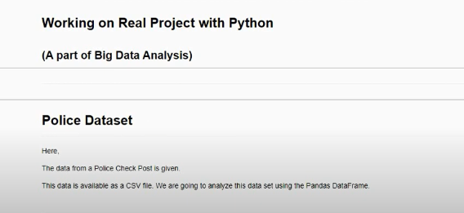

Instruction (For Data Cleaning)

1. Remove the column that only contains missing values



Question (Based on Filtering + Value Counts)

2. For Speeding, were Men or Women stopped more often ?

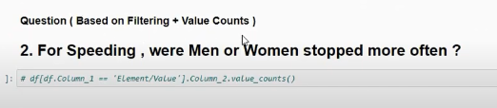

Question (Groupby)

3. Does gender affect who gets searched during a stop?

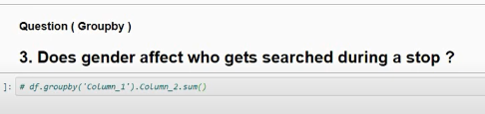

Question (mapping + data-type casting)

4. What is the mean stop_duration ?

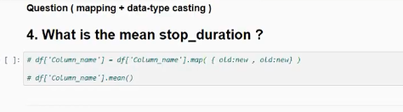

Question ( Groupby, Describe )

5. Compare the age distributions for each violation

